Create a windows Vm machine in AWS and connect with RDP open CMD in windows share the about system info.

Objective
The objective of this task is to create and configure a Windows Virtual Machine (VM) on AWS EC2, establish a Remote Desktop (RDP) connection to the instance, and use the Windows Command Prompt to retrieve and verify the system information.
Step 1:
Launch a Windows EC2 Instance
- Navigate to EC2 → Instances → click Launch Instance
- Name: windows-vm
- AMI: Microsoft Windows Server 2022 Base
- Instance Type: t3.nano
- Key Pair: Create or use an existing key pair (download the .pem file)
- Security Group: Allow RDP (Port 3389)
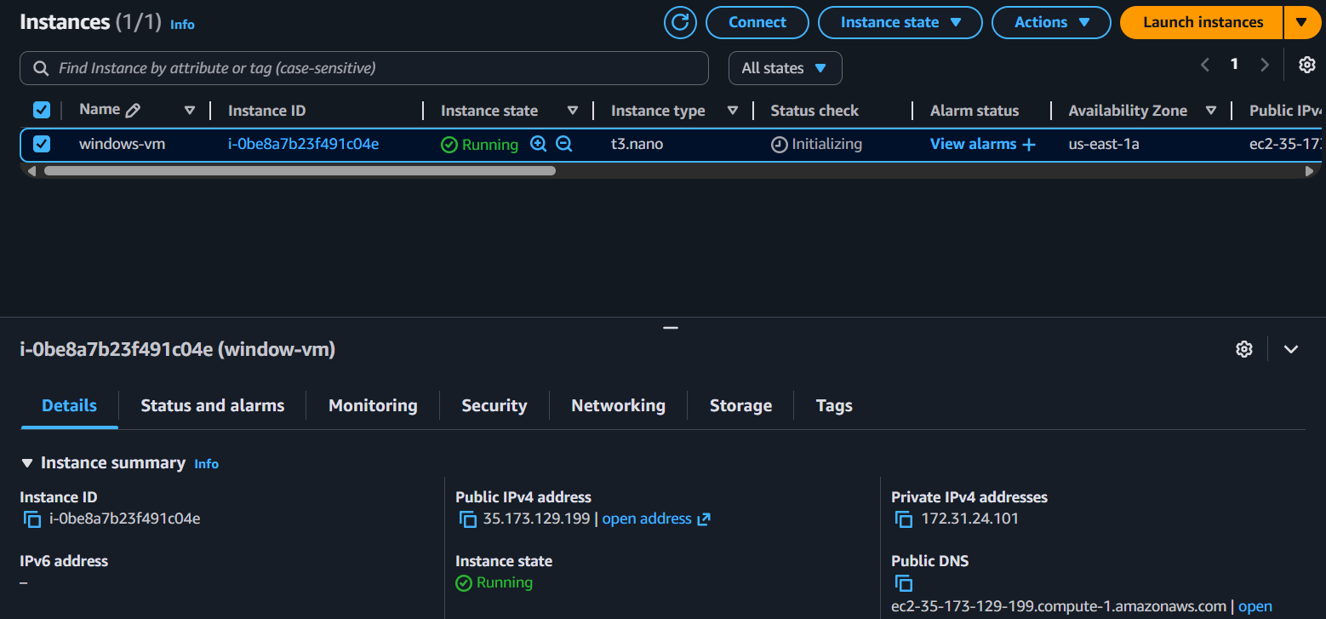
Step 2:
Connect to the Instance using RDP
- Go to EC2 → Instances.
- Select your instance and click Connect → RDP client.
- Click Get password and decrypt it using your .pem file.
- Copy the Public IPv4 address and username (Administrator).
- Open Remote Desktop Connection on your local system:
  - Computer: <public-ip>
  - Username: Administrator
  - Password: (from decrypted key
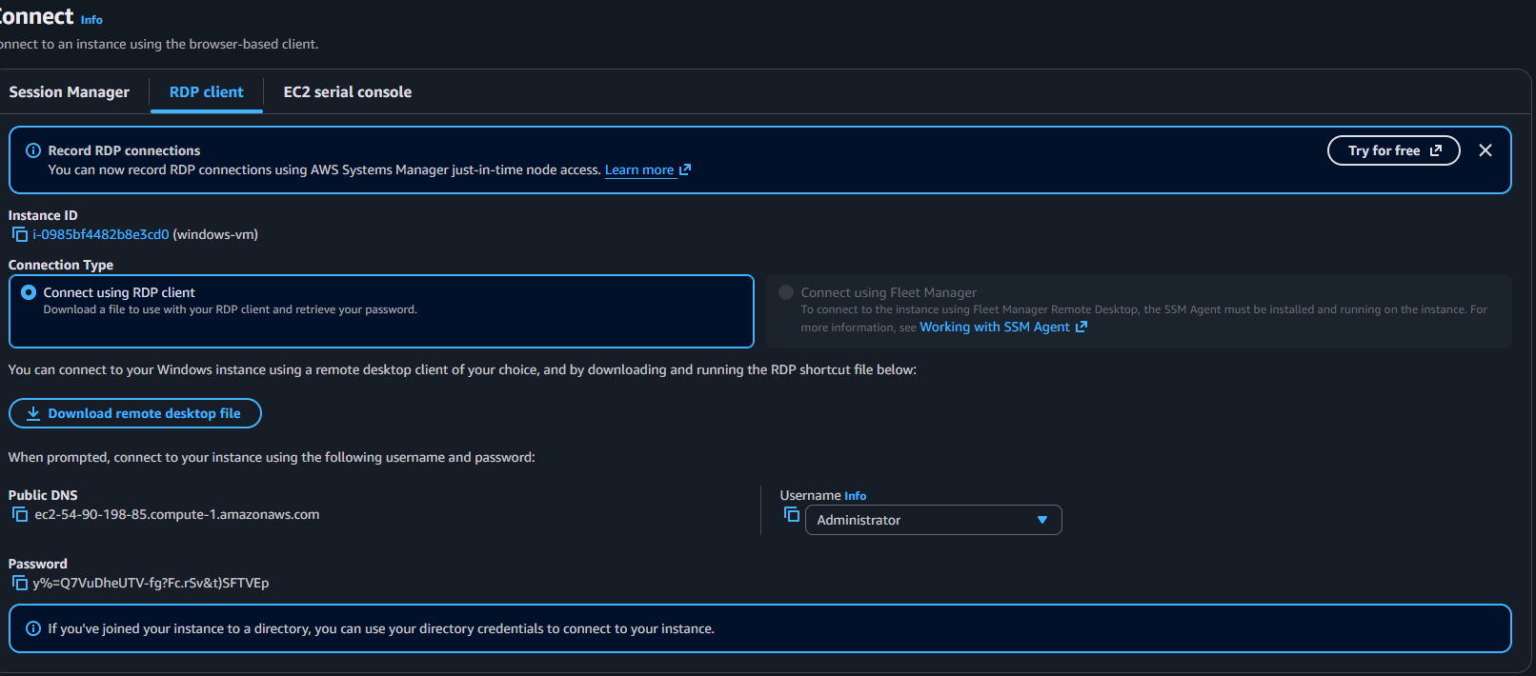

RDP Connection :
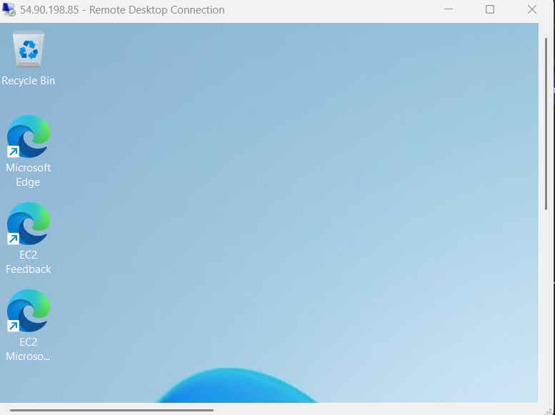

Step 3:
Open Command Prompt & Display System Info
- Inside the Windows VM, press:
  - Win + R
  - Type "cmd" → Enter
  - Type systeminfo in cmd
Output :
